VALID FORMS OF ID TO ENTER BASE
Real – ID OR Enhanced ID (Only one needed)

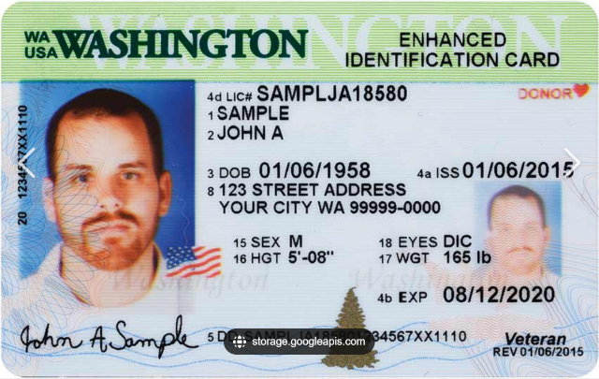
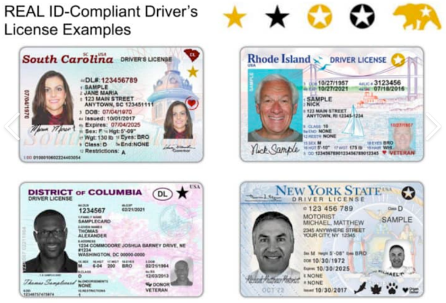

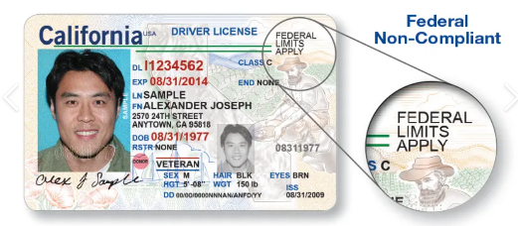

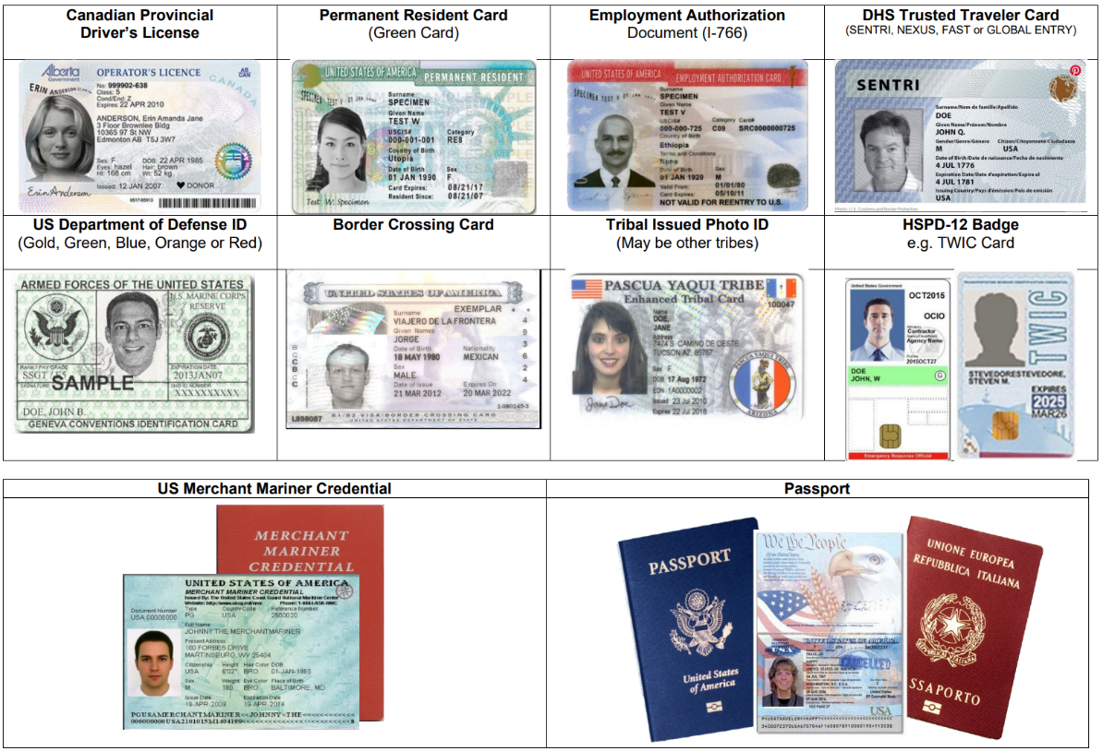
Federal Limits Apply ID’s are not authorized forms of ID!!
They must also provide one of the following Federal ID’s:
Veteran’s Health ID Card
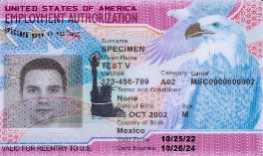
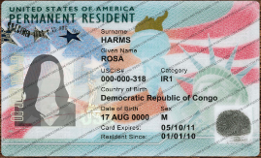
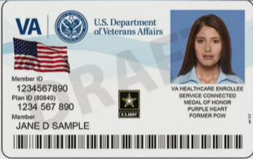

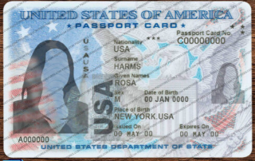
Passport Card

Certificate of Naturalization
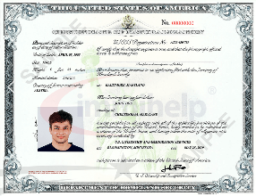

SSN CARDS AND BIRTH CERTIFICATES DO NOT COUNT AS ID!!!!

